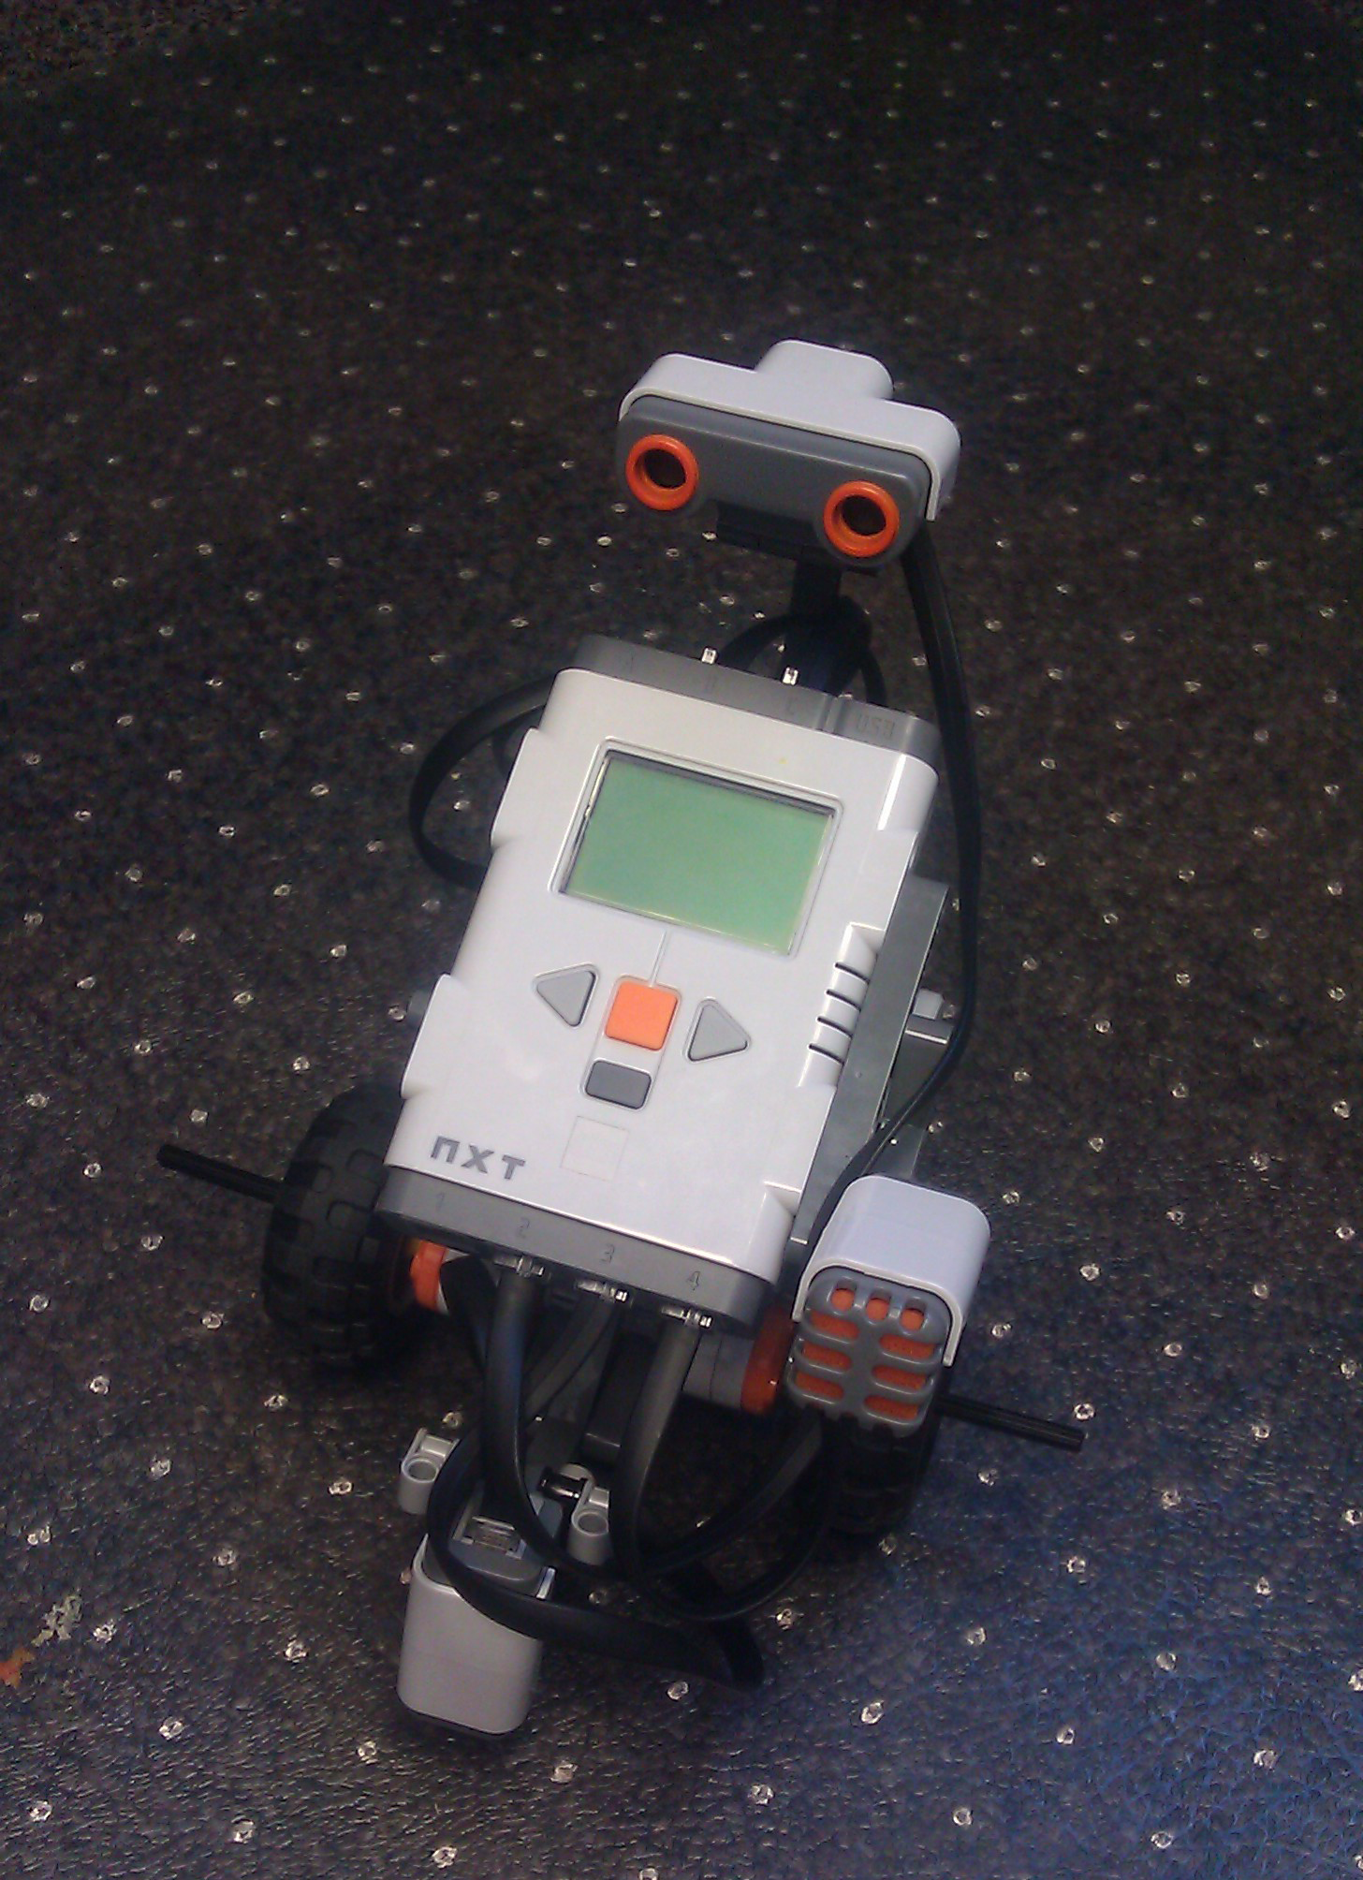
Name __________________ Team Name __________________
Grade ______ Lego Kit Number ____________
Age ________

At the beginning of each day…
- Check out your team’s Lego kit
- Search the area for Lego pieces

Date: ___________________________
Checked out by: ___________________________
Returned by: ___________________________
Date: ___________________________
Checked out by: ___________________________
Returned by: ___________________________
Date: ___________________________
Checked out by: ___________________________
Returned by: ___________________________
Date: ___________________________
Checked out by: ___________________________
Returned by: ___________________________
Date: ___________________________
Checked out by: ___________________________
Returned by: ___________________________
Date: ___________________________
Checked out by: ___________________________
Returned by: ___________________________
Date: ___________________________
Checked out by: ___________________________
Returned by: ___________________________
Date: ___________________________
Checked out by: ___________________________
Returned by: ___________________________
Date: ___________________________
Checked out by: ___________________________
Returned by: ___________________________
Date: ___________________________
Checked out by: ___________________________
Returned by: ___________________________
Date: ___________________________
Checked out by: ___________________________
Returned by: ___________________________
Date: ___________________________
Checked out by: ___________________________
Returned by: ___________________________

Learning Log
At the end of each day, after you return your Lego Kit, fill in the date and write down two things you learned that day.
Today’s date _____________________
What did I learn today?

Today’s date _____________________
What did I learn today?

Today’s date _____________________
What did I learn today?

Today’s date _____________________
What did I learn today?

Today’s date _____________________
What did I learn today?

Today’s date _____________________
What did I learn today?

Today’s date _____________________
What did I learn today?

Today’s date _____________________
What did I learn today?

How to Create a New Program
- Go up to the top left of the screen and click on “File”
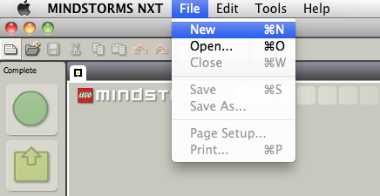
- Click on “New”

OR 1. Begin typing a name for the new program in the box below.
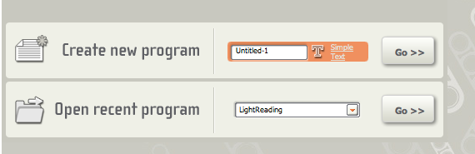

OR 1. Click on the “New File” Icon as show below

New File

How to Save Your Current Program
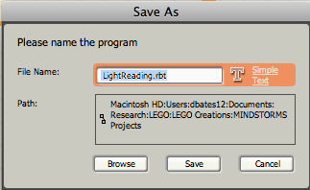
- Go up to “File”
- Click on “Save”
- Name your file and click “Browse”
- Choose “Desktop”
- Click “OK”
- Click “Save”

Planning
The first part in creating any program is to plan it out. Use this sheet to plan out your human robot.

Goal

Program the human robot to go across the room and sit down on a chair

What functions will I use?

Forward
Turn left 90 degrees
Turn right 90 degrees
Sit down

Plan the process:

Analysis

Use the following chart to record the changes you make. Once you get the robot to go across the room and sit on the chair can you make it more efficient?

Did it go across the room? | Did it sit down? | Changes made | Reason | Result

Planning
The first part in creating any program is to plan it out. Use this sheet to plan out your robot.

Goal

Program on the brick to make your robot

Go from line a to line b
- Go from line a to line b and return back to line a

What functions will I use?

Forward 5
Backward 5
Empty or Wait 2
Stop or Loop

Plan the process:

Analysis

Use the following chart to record the changes you make. Once you get the robot to go to line B and back can you make it more efficient?

Did it go from line a to line b? | Did it go from line b back to line a? | Changes made | Reason | Result

GOAL: Make a robot that can go from line A to line B, turn around, go back to line A, turn around, and stop.

Building
- Build the basic model from the Lego NXT Mindstorms 2.0 Education manual.

Functions
New Functions that you’ll need for this robot:

The Move Function
The move function controls the motors. It can make the robot move. This function determines which motors are running and with how much power and for how long.
Input: The signal to start
Process: Turns the motors on for the desired time
Output: The robot moves

Move Function Variables
Port: Let’s you choose which motors to turn on
Direction: Choose which direction to go: forward, backward, or stop
Steering: Allows you to steer towards one motor
Power: Choose at how much power to run the motors
Duration: Choose how long to run the motor based on seconds, rotations, degrees, or run unlimited.
Next Action: Choose between brake and coast for the next action

Planning
The first part in creating any program is to plan it out. Use this sheet to plan out your robot.

Goal

Make a robot that can go from line A to Line B, turn around, go back to line A, turn around, and stop

What functions will I use?

Move 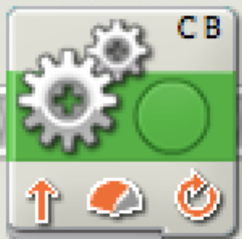

Plan the process:

Analysis

Use the following chart to record the changes you make. Once you get the robot to go to line B and back can you make it more efficient?

Did it make it to line B? | Did it turn 180 degrees? | Changes made | Reason | Result

GOAL: Make a robot that moves forward when the touch sensor is pushed and stops when the sensor is released.

Building
New pieces that you’ll need for this robot:

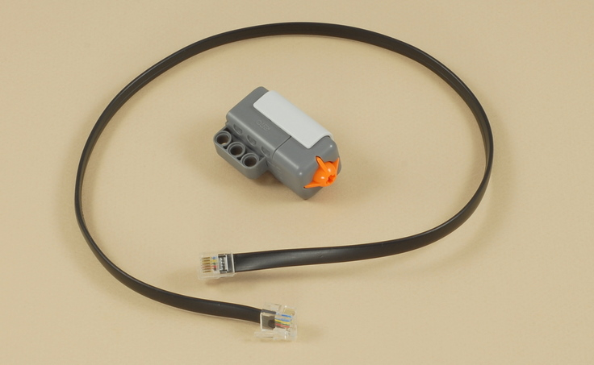
Touch Sensor
The touch sensor can detect when the button is pushed down, released or pushed and released.

1. Plug the touch sensor into port 1.

Functions
New Functions that you’ll need for this robot:

The Loop Function
The loop function causes all the functions that are placed inside it to repeat.

Input: The functions placed inside.
Process: Once it reaches the end of the loop, it goes back to the beginning of the loop.
Output: It repeats everything placed in the loop function.

Loop Function Variables
Control: If this is set to forever, it will repeat forever. You can also set it to run a specific number of times or seconds.

The Switch function
The switch function works like the words EITHER…OR. It checks a condition and it EITHER does something if the condition is true, OR it does something else if the condition is false.
Input: Something from a sensor (light, sound, touch, ultrasonic)
Process: check to see if the sensor input matches the conditions you tell it.
Output: True or False

Switch Function Variables
Control: Let’s you choose to wait for a sensor or wait for time
Sensor: Chooses which sensor to wait for
Display: Chooses whether to show the process for true and false conditions at the same time or separately.
Port: Indicates which port the sensor should be plugged into on the robot
Until: Indicates the condition to wait for. In this case, it’s waiting for light greater than 50%
Function: Tells the sensor to generate light or not.

Planning
The first part in creating any program is to plan it out. Use this sheet to plan out your robot.

Goal

What sensors will I need?

What functions will I use?
Move Loop 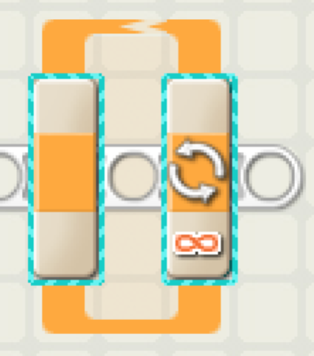 Switch 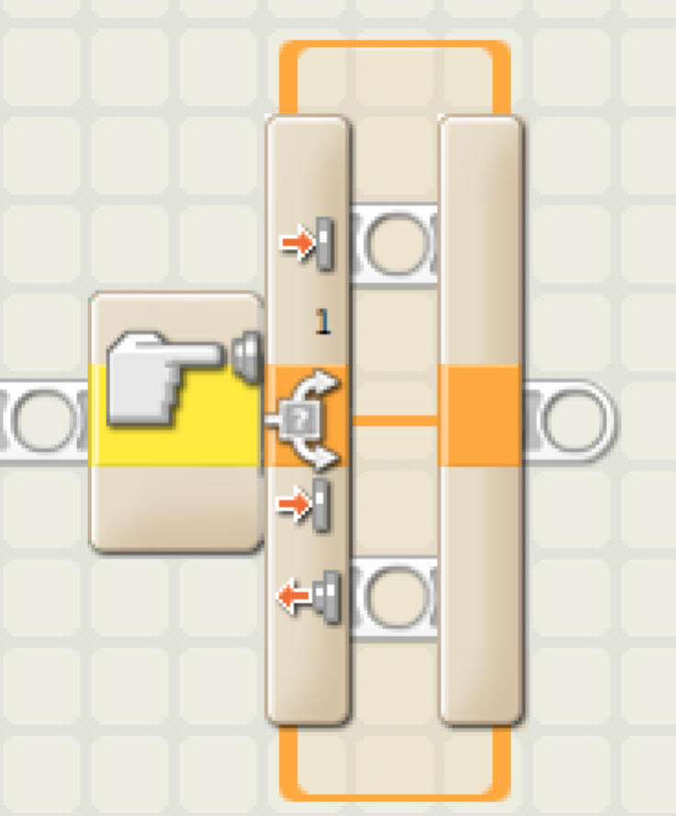

Plan the process:

Programming
- Place a loop on the canvas.
- Place a switch function inside the loop.
- Set the variables.
  - Control: Make sure this is set to sensor.
  - Sensor: Make sure this is set to Touch Sensor.
  - Port: Make sure port 1 is selected.
  - Action: Make sure pressed is selected.
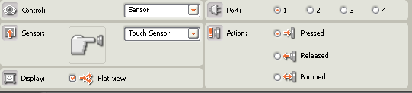

- Place a move function inside the top section of the switch.
- Set the variables to make it go forward.
  - Duration: Set this to unlimited.
  - Port: make sure these are set to the right ports
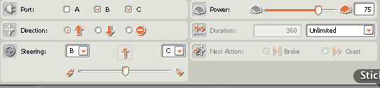
- Place a move in the bottom section of the switch.

- Set the variables so that it stops.
  - Direction: Select the stop sign.

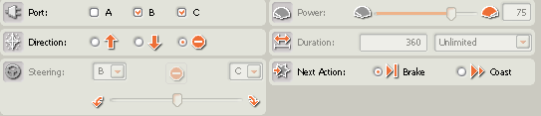

Push and Go (final)
Your completed program should look like the following:
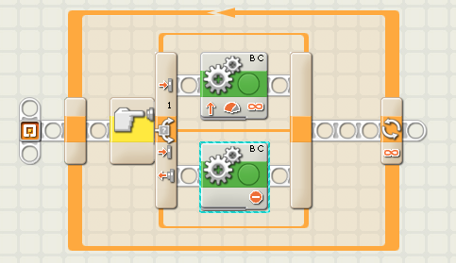

Analysis

Use the following chart to record the changes you make. Once it works, what else can you do?
Does it go when you push down? | Does it stop when released? | Changes made | Reason | Result

GOAL: Create a robot that will follow a black line using the light sensor.

Building the Line Following Robot
- Complete pages 32-34 in your Lego Mindstorms Education manual.

New pieces that you’ll need for this robot

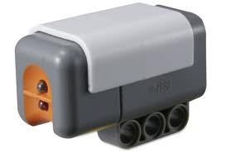
Light Sensor
The light reading sensor detects how much reflected light there is on a surface. It provides a numeric value between 0% and 100%

Planning
The first part in creating any program is to plan it out. Use this sheet to plan out your robot.

Goal

What sensors will I need?

What functions will I use?

Plan the process:

Programming

Line Following Final
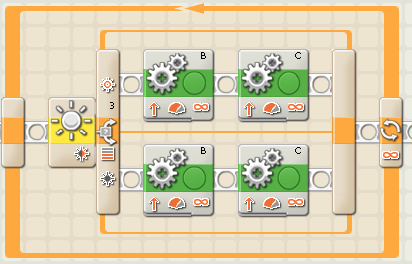
- Follow the picture to set up the program
- Set the variables of the Switch function
  - Set Sensor to Light Sensor
  - Set Compare to a number that is less than the reflected light from the table and more than the reflected light from the black line
Hint: Use the brick to test the reflected light
- Set the variables for the Move functions
  - Set Duration to unlimited for all move functions
  - As seen in the picture select only one motor for each move function, so the first move function on top the Port should be set to B, and for the second one the Port should be set to C (repeat for the bottom Move functions.
  - For the top move functions- set motor B power to greater than 50%, and motor C power to less than 50%
  - For the bottom move functions- set motor B power to less than 50%, and motor C power to greater than 50%
Why are the power variables set to different numbers?

Can you make the robot complete the course faster?

Analysis
Use the following chart to compare the times your robot gets on the different courses.

Course | Time | Changes made | Reason | Result

GOAL: Create a robot that will start moving forward when it hears a sound and turn when it gets close to something, before continuing on.

Building
- Follow pages 24-26 of your Lego Mindstorms Education manual.
- Follow pages 28-30 of your Lego Mindstorms Education manual.
New pieces that you’ll need for this robot:

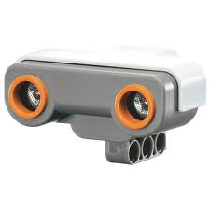
Ultrasonic Sensor
The ultrasonic sensor detects how far away something is from the “eyes” of the sensor.

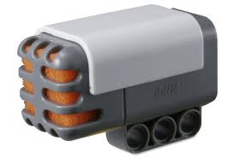
Sound Sensor
The Sound sensor will detect how loud a noise is.

Programming
New Functions that you’ll need for this robot:

The Switch function
The switch function works like the words EITHER…OR. It checks a condition and it EITHER does something if the condition is true, OR it does something else if the condition is false.
Input: Something from a sensor (light, sound, touch, ultrasonic)
Process: check to see if the sensor input matches the conditions you tell it.
Output: True or False

Switch Function Variables
Control: Let’s you choose to wait for a sensor or wait for time
Sensor: Chooses which sensor to wait for
Display: Chooses whether to show the
Port: Indicates which port the sensor should be plugged into on the robot
Until: Indicates the condition to wait for. In this case, it’s waiting for light greater than 50%
Function: Tells the sensor to generate light or not.

Functions
New Functions that you’ll need for this robot:

The WAIT function
The Wait function is used to tell your robot to wait for a certain input before proceeding. You can choose to have the robot wait for a certain period of time or to wait for any sensor.
Input: Something from a sensor (light, sound, touch, ultrasonic)
Process: check to see if the sensor input matches the conditions you tell it.
Output: Advance the robot to the next function

Wait Function Variables
Control: Let’s you choose to wait for a sensor or wait for time
Sensor: Chooses which sensor to wait for
Port: Indicates which port the sensor should be plugged into on the robot
Until: Indicates the condition to wait for. In this case, it’s waiting for light greater than 50%
Function: Tells the sensor to generate light or not.

Planning
The first part in creating any program is to plan it out. Use this sheet to plan out your robot.

Goal

What sensors will I need?

What functions will I use?

Plan the process:

Analysis

Use the following chart to record the changes you make. Once it works, what else can you do?

Did it respond to a sound by moving? | Did it turn when it got close to something? | Changes made | Reason | Result

GOAL: Make a robot that reads and displays reflected light.

Building
1. Attach the light sensor.

Functions
New Functions that you’ll need for this robot:

The DISPLAY function
The Display function allows something to be displayed on the screen on the brick.

Input: A variable
Process: communicates with the brick
Output: Displays something on the screen

Display Function Variables
Action: Let’s you choose what type of information will be displayed
Display: Determines if the screen should be cleared first
File/Text/Type: Set what is displayed
Position: Set the position on the screen where something is displayed

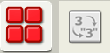
The NUMBER TO TEXT function
The Number to Text function is used change a number variable into a text variable.

Input: A number variable
Process: Converts a number variable to a text variable
Output: A text variable

Number to Text Function Variables
Number: Let’s you manually set the number

The LIGHT SENSOR function
The Light Sensor function uses the Light Sensor to detect how much light is reflected.

Input: Light from the light sensor
Process: Converts the amount of reflected light into a number
Output: A number variable

Light Sensor Function Variables
Port: Let’s you choose which port the light sensor is in
Compare: Set what is considered light or dark
Function: Choose whether or not the light sensor generates light

Planning
The first part in creating any program is to plan it out. Use this sheet to plan out your robot.

Goal

What sensors will I need?

What functions will I use?

Plan the process:

Programming

Light Reading Final
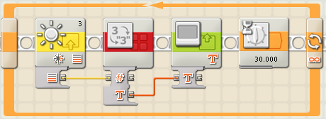
- Set your program up like the picture.
- Connect the wires
- Set the variables for the Light function
  - Port: Set to which port you are using.
  - Compare: Leave default settings.
  - Function: Select Generate Light.

- Set the variables for the Display function
  - Action: Set to Text
- Set the variables for the Wait function
  - Control: Set to time
  - Until: Set how much time you want it to wait before continuing on

RECORDING THE LIGHT READING

Analysis
Instructions: For this activity, you will explore how much light comes from the different colors of the different objects in the room. Use the table below to record the value of different colored items throughout the room. Try to measure a range of light to dark objects.
Location | Color | Light reading
1.
2.
3.
4.
5.
6.
7.
8.
9.
10.

What could this be used for in real life?
How could this program be improved?

GOAL: Create a robot that will count how many times a person can press a button in 10 seconds

Building
1. Attach the touch sensor.

Functions
New Functions that you’ll need for this robot:

The SOUND function
The Sound function allows a tone or sound file to be played.

Input: A variable
Process: communicates with the brick
Output: Displays something on the screen

Display Function Variables
Action: Let’s you choose what type of information will be played
Control: Determines if the sound starts or stops playing
Volume: Adjusts the volume
Function: Allows it to be set to repeat
File: Choose sound file
Wait: Allows the program to wait until the sound is done playing

Planning the Touch Count Robot
The first part in creating any program is to plan it out. Use this sheet to plan out your robot.

Goal?

What sensors will I need?

What functions will I use?

Plan the process:

Analysis

Use the following chart to record the changes you make. Once it works, what else can you do to make it more efficient? Explore other sensors or make up your own variable.

Did it count the number of presses for the button? | Did it display a count and stop after 10 seconds? | Changes made | Reason | Result

Touch Count (final)
Goal: Create a robot that will count how many times a person can press a button in 10 seconds
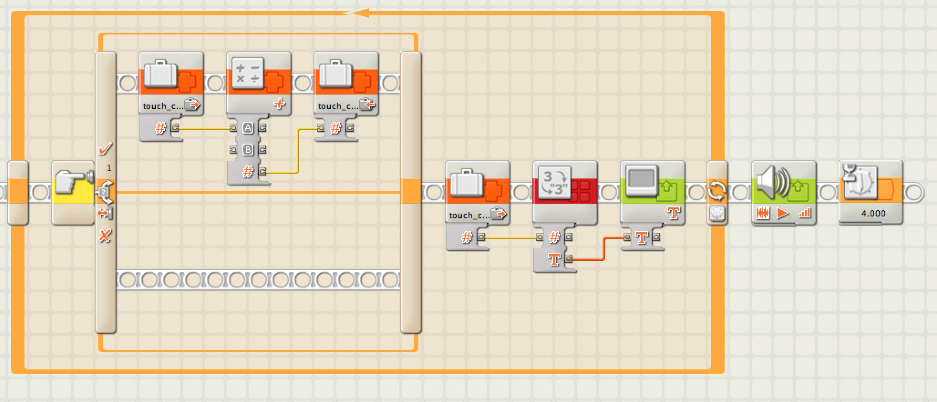

- Set up the program in the picture
- Create a new variable
  - Go to Edit and select Define Variable.
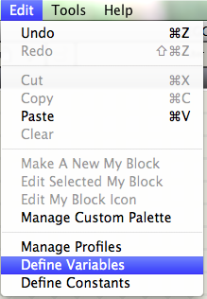
  - Click the Create button.
  - Name the variable touch_count.
  - Set the Datatype to Number.
  - Click Close.
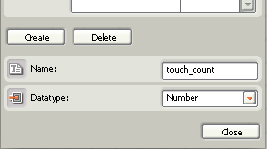
- Set the Loop to repeat for 10s.
- Switch function
  - Set Action to Bumped
- All Variable functions
  - Select touch_count
- 2nd Variable function
  - Set Action to Write
- Connect the wires
- Math function
  - Set B to 1
- Display function
  - Set Action to Text
- Choose a sound file for the Sound function.

- Set the Wait function to 4s.
How many times can you push the button in 10s?
Challenge
- Have it add 2 points for every click.
- Use a different sensor and create an appropriate variable.

GOAL: Create a robot that will go back and forth between two pieces of black tape as many times as possible in 15 seconds.

Building
1. Attach the light sensor.

Functions

Planning the Back and Forth robot

Goal?

What sensors will I need?

What functions will I use?

Plan the process:

Analysis

Use the following chart to record the changes you make. Once it works, what else can you do to make it more efficient? Explore other sensors to use. Is there a way to count how many times it went back and forth?

Did it go back and forth between two black pieces of tape? | Did it loop back and forth until the end of 15 seconds? | Changes made | Reason | Result

Complete Back and Forth program
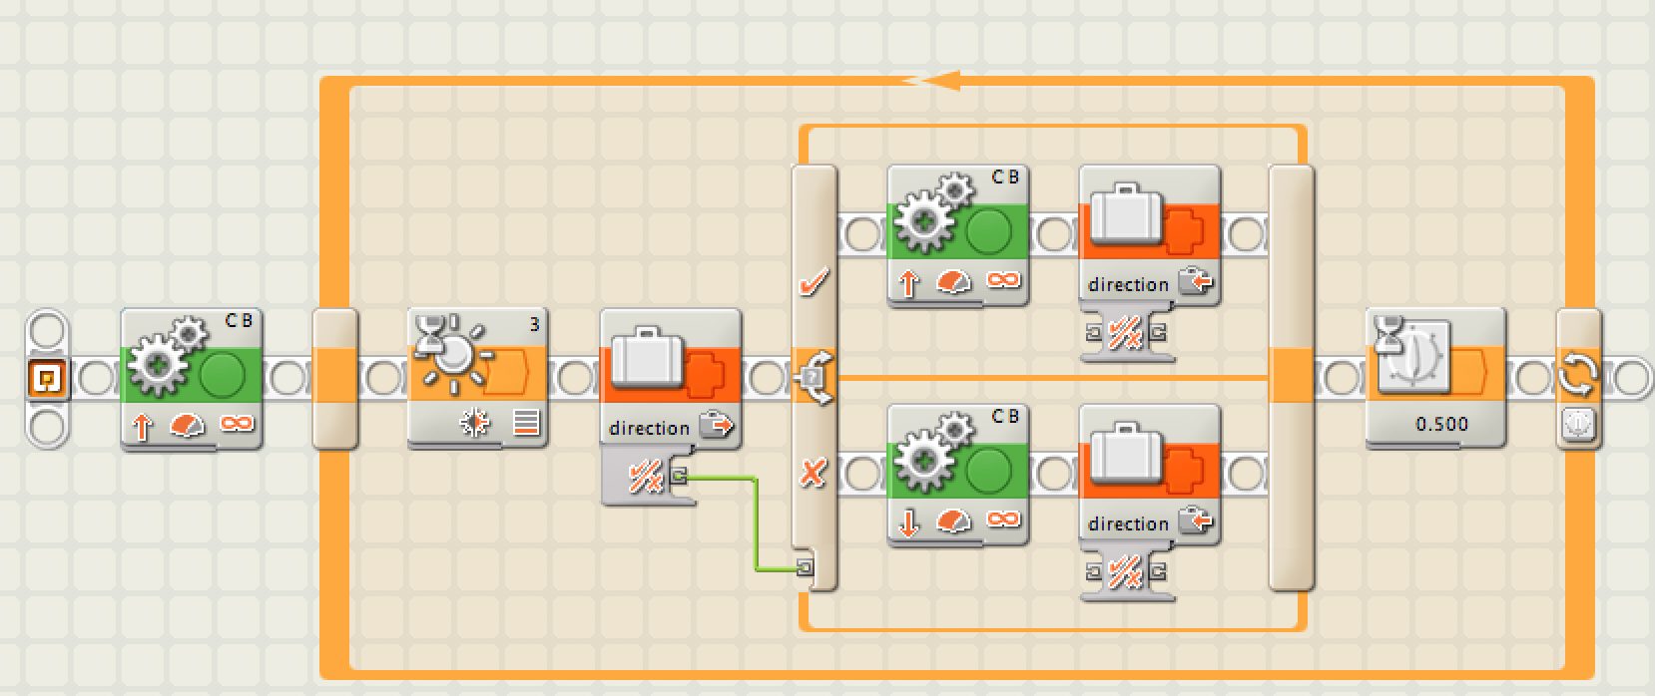
Your completed Back and Forth program should look something like the following. Download it to your robot and try it out!

CHALLENGE In an earlier program (touch count), we made it so the robot could count how many times it did something and we displayed that on the screen. Can you make it so the Back and Forth robot shows you how many times it changes direction?

